Proposal Group – Select and Assign Reviewers in a Tier

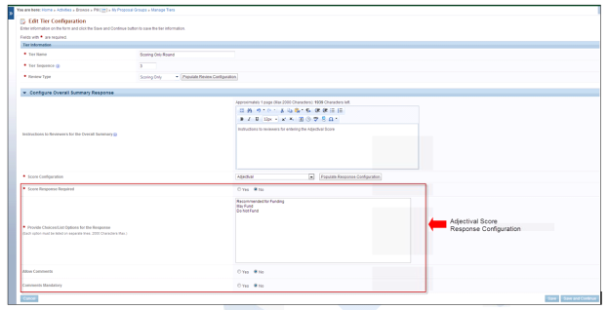
Figure 5-1. Edit Tier Configuration (Scoring Only Review), Adjectival Score
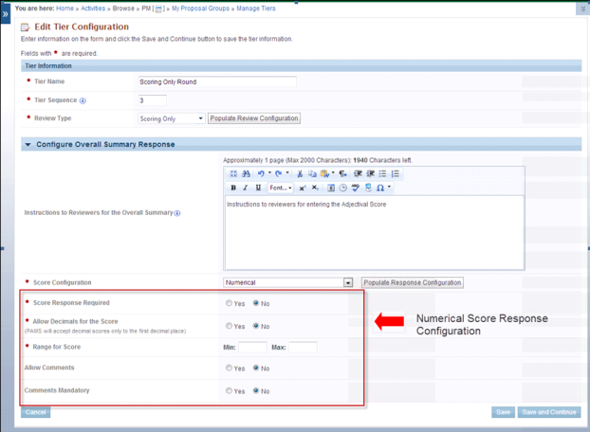
Figure 5-2. Edit Tier Configuration (Scoring Only Review), Numerical Score

Manage Tiers – Select Reviewers

Select Reviewers
- Click the Actions/Views link on the Manage Tiers tab.
- Click the Select Reviewers link to add reviewers to the tier. These reviewers will be assigned to Proposals for review.
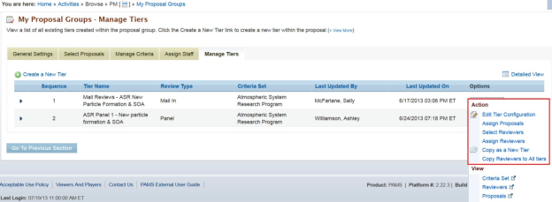
Figure 1. My Proposal Groups - Manage Tiers (Actions/Views Link)
Notable Page Elements
Create a New Tier link | Click the Create a New Tier link to start creating a new tier within the Proposal Group. This takes you to the Edit Tier Configuration page.
Select Reviewers action link | Click this link to add reviewers to the tier. The selected reviewers can be assigned to proposals using the Assign Reviewers action.
Options context menu | Click the Actions/Views link in the Options column for a list of actions that can be performed on the tier of choice.
Continue button | Click the Continue button at the bottom right of the page to navigate to the Assign Staff tab of the Proposal Group.
Go To Previous Section button | Click the Go To Previous Section button at the bottom left of the page to navigate to the Manage Criteria tab of the Proposal Group.

Manage Tiers - Assign Reviewers

Assign Reviewers
- Click the Actions/Views link on the Manage Tiers tab.
- Click the Assign Reviewers link to go to the Assign Reviewers page. You can perform assignments either by Proposals (go to Step 3 below) or by Reviewers (go to Step 4 below).
- Click the By Proposals tab to perform assignments by Proposals.
- On the By Proposals tab for a Proposal, click the Actions/Views link in the Options column.
- Click the Manage Assignments link, which takes you to the Reviewer Assignments - Manage Assignments by Proposal page.
- Click the Add Reviewers link, above the grid at left, to assign reviewers to the Proposal. You will be presented with a search page. To see a list of all possible reviewers already listed in the system, click Search with no parameters added. To narrow the list of reviewers, enter parameter(s) into the appropriate fields and click Search.
- When finished, go to Step 5.
OR
- Click the By Reviewers tab to perform assignments by reviewers.
- On the By Reviewers tab for a reviewer, click the Actions/Views link in the Options column.
- Click the Manage Assignments link, which takes you to the Reviewer Assignments - Manage Assignments by Reviewer page.
- Click the Add Proposals link, above the grid at left, to assign Proposals to the reviewer.
- Continue to Step 5.
- On the Choose Action dropdown, select the Send Proposals for Review option and click the Go button to create review tasks for the assignments made.
Figure 1. My Proposal Groups - Manage Tiers (Actions/Views Link)
Notable Page Elements
Create a New Tier link | Click the Create a New Tier link to start creating a new tier within the Proposal Group. This takes you to the Edit Tier Configuration page.
Assign Reviewers action link | Click this link to assign reviewers to proposals within the tier. You may start with proposals and assign reviewers to them; i.e., the By Proposals approach or start with reviewers and assign proposals to them; i.e., the By Reviewers approach.
Options context menu | Click the Actions/Views link in the Options column for a list of actions that can be performed on the tier of choice.
Continue button | Click the Continue button at the bottom right of the page to navigate to the Assign Staff tab of the Proposal Group.
Go To Previous Section button | Click the Go To Previous Section button at the bottom left of the page to navigate to the Manage Criteria tab of the Proposal Group.
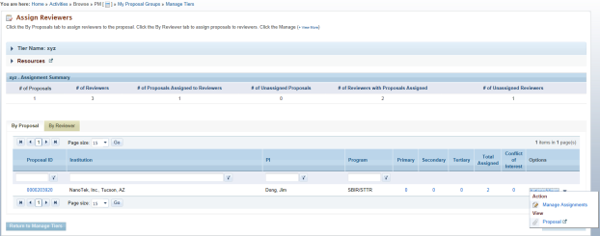
Figure 2. Assign Reviewers By Proposal
Notable Page Elements
Proposal ID link | Click the Proposal ID link to view a list of all reviewers assigned to the proposal on the By Reviewers tab.
Primary, Secondary, Tertiary count links | Click the link to view the list of all reviewers assigned to the proposal under the Primary, Secondary and Tertiary categories.
Total Assigned count link | Click this link to view a list of all reviewer assigned to the proposal within the proposal group.
Conflict of Interest count link | Click this link to view a list of all reviewers who have a conflict with the proposal.
Manage Assignments action link | Click this link to navigate to the Manage Assignments - By Proposal page. You may change the reviewer assignments for the proposal from this page.
Return to Manage Tiers button | Click this button to return to the Manage Tiers page within the proposal group.

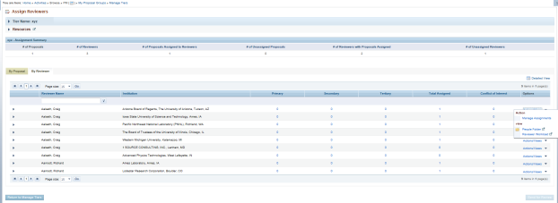
Figure 3. Assign Reviewers By Reviewer
Notable Page Elements
Primary, Secondary, Tertiary count links | Click the link to view the list of all proposals assigned to the reviewers under the Primary, Secondary and Tertiary categories.
Total Assigned count link | Click this link to view a list of all proposals assigned to the reviewer within the proposal group.
Conflict of Interest count link | Click this link to view a list of all proposals who have a conflict with the reviewer.
Manage Assignments action link | Click this link to navigate to the Manage Assignments - By Reviewer page. You may change the proposal assignments for the reviewer from this page.
Return to Manage Tiers button | Click this button to return to the Manage Tiers page within the proposal group.

Start and Stop Scoring
- Click the Actions/Views link on the Manage Tiers tab.
- Click the Manage Proposal Scores link to go to the Manage Proposal Scores page.
- Click Start Scoring to send the scoring review assignments. Once sent, this button will be greyed out. Select Stop scoring to end the scoring task.
